SIMATS ENGINEERING
ASSESSMENT TOOL 1

COURSE NAME: INTERNET PROGRAMMING
COURSE CODE: CSA43

COURSE OUTCOME COVERED

CO 4: Formulate data-driven web solutions using XML, XSLT, and JSP within the MVC framework.(L4)

Assessment Tool : Comparative Analysis (BL4)

Weightage: 40%

QUESTIONS: ANSWER ANY THREE Total Marks: 30
- A company intends to transform and present XML data as structured web reports for end users. Critically analyze and compare XSLT-based transformation with JavaServer Pages-based dynamic rendering approaches. Your analysis should examine the underlying processing models, execution flow, and transformation mechanisms, along with their impact on system performance and resource utilization. Further, evaluate the flexibility of each approach in handling complex data transformations and discuss suitable real-world scenarios where each technique would be most effective.

An e-commerce platform requires a robust and scalable architecture to handle high user traffic and dynamic data processing. Perform a detailed comparative analysis of the Model-View-Controller implementation using JSP/Servlets and modern PHP frameworks such as Laravel or Symfony. Your discussion should focus on architectural design principles, separation of concerns, scalability under increasing workloads, maintainability of codebases, and efficiency in data handling and integration with backend systems.

In a system where structured data must be validated before storage, critically compare XML Schema-based validation with database-level validation techniques implemented through JSP/JDBC or PHP-based systems. Analyze how each approach ensures data integrity, handles validation complexity, and impacts overall system performance. Additionally, evaluate their effectiveness in real-time environments where immediate validation and response are critical.

- A web application processes large XML documents that require efficient parsing and transformation. Provide a comprehensive comparative analysis of DOM parsing, SAX parsing, and XSLT-based transformation techniques. Your discussion should critically evaluate memory consumption, processing speed, suitability for large-scale data handling, and implementation complexity, highlighting the trade-offs involved in selecting each approach.

- A company is developing a data-driven web application that must efficiently render dynamic content to users. Critically compare traditional server-side rendering approaches using JSP/PHP with XML-based transformation techniques such as XSLT. In your analysis, discuss differences in performance, scalability under concurrent user loads, impact on user experience, and overall development complexity. Conclude by recommending the most appropriate approach for modern web application development scenarios.

Code of Conduct:

I G.CHAKRADHAR(192311439) certify that this submission is my original work and that I have adhered to the guidelines specified for this assessment.
I understand that any violation of academic integrity rules will result in disciplinary action.

Signature of the student:

RUBRICS FOR CALCULATION:

 |  | Comparative analysis
Criteria | Weightage (%) | Level 4 (Exemplary) | Level 3 (Proficient) | Level 2 (Developing) | Level 1 (Beginning)
Scope of Items | 20% | Selects highly relevant items with clear scope and justification | Selects appropriate items with minor gaps | Selection is limited or partially relevant | Items are unclear or not relevant
Comparison Depth | 25% | Provides detailed and comprehensive comparison across multiple aspects | Provides adequate comparison with some depth | Limited comparison with few aspects | Very minimal or no comparison
Use of Evidence | 20% | Supports comparison with accurate data, examples, or references | Uses some supporting evidence with minor gaps | Limited or weak supporting evidence | No supporting evidence provided
Critical Thinking | 20% | Demonstrates strong critical thinking with clear interpretation and reasoning | Shows reasonable interpretation with minor gaps | Basic interpretation; lacks depth | No meaningful interpretation
Clarity of Presentation | 15% | Well-organized, clear, and logically structured presentation | Generally clear with minor issues | Somewhat unclear or poorly structured | Disorganized and difficult to understand

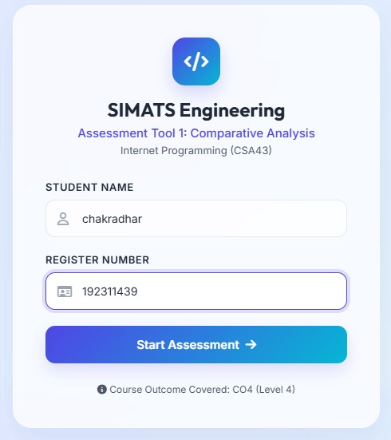

Question-1:

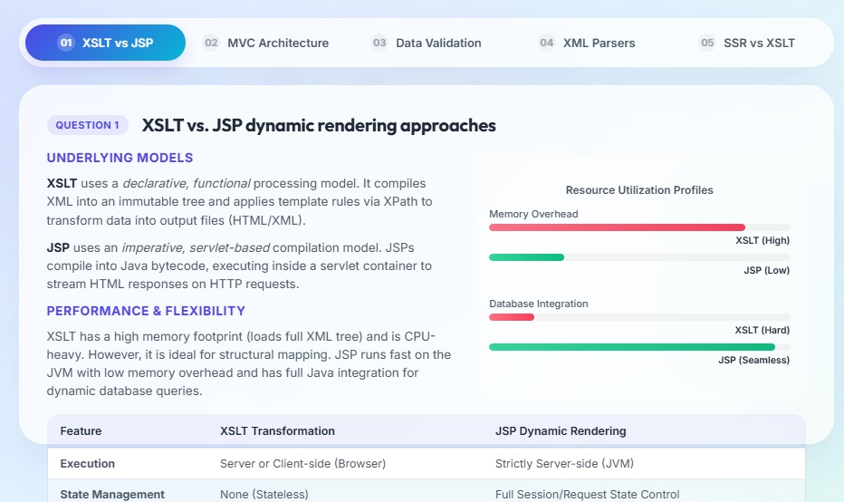

Question-2:

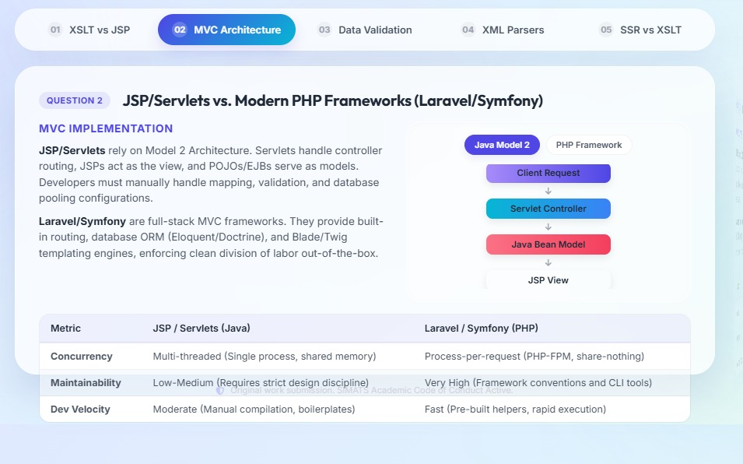

Question-3:

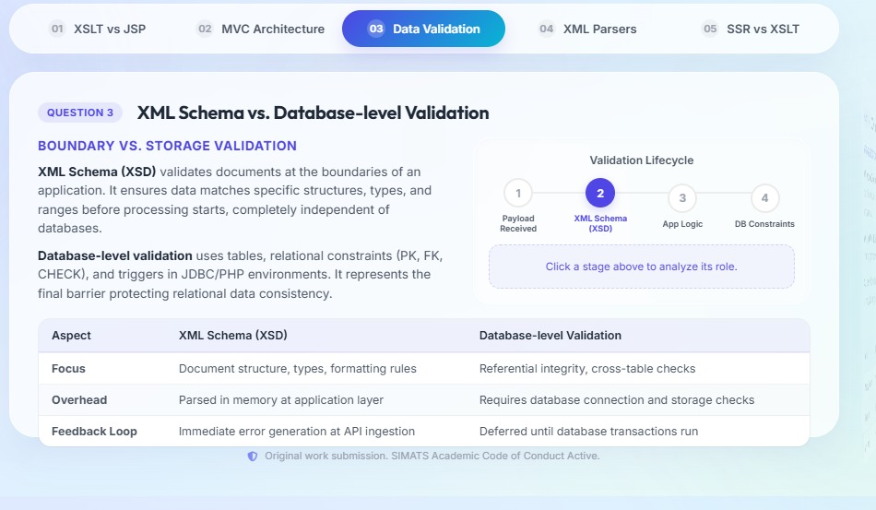
Question-4:

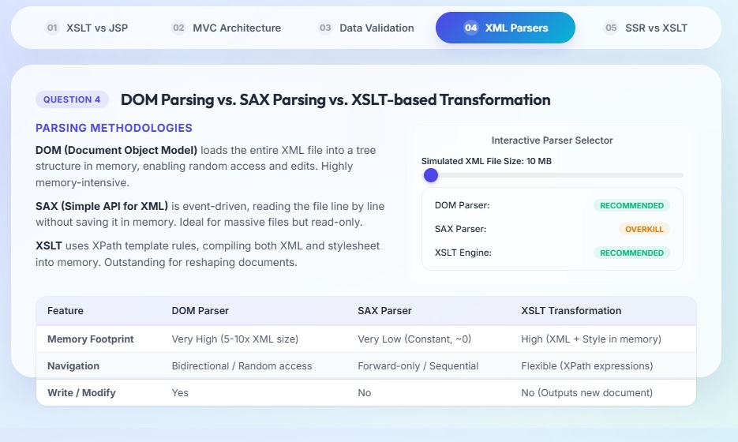

Question-5:

